Title of the talk

First A. Author¹*, Second B. Author², Third C. Author²

¹Institution, City, Country of First Author
²Institution, City, Country of Second and Third Author
*email address of presenting author

Here starts the text of the abstract in 11 pt Times New Roman, single-spaced, justified.
The title of the abstract should be in 14 pt Times New Roman with lower case letters, bold, single-spaced, centered, one blank line after.
The list of authors should be in 11 pt Times New Roman and formatted as in the example (presenting author underlined, first names abbreviated, single-spaced, centered, one blank line after).
The affiliation should be in 11 pt Times New Roman, singled-spaced, centered, one blank line after. It should contain the institution, city and country of the authors, and the email address of the presenting author.
Only one figure allowed. The caption title should be written centered, in 10 pt Times New Roman with lower case letters.
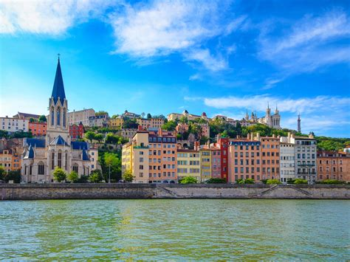

Figure 1: Figure caption

References should be in this style: [1, 2], and formatted as in the examples given below.

Your abstract should be no more than one A4 page in length.

References
- A. Author, B. Author: Title of the reference in lower case letters, italics. Name of the Journal Volume number, page range (year)
- F. Cichos, K. Gustavsson, B. Mehlig, G. Volpe: Machine learning for active matter. Nature Machine Intelligence 2, 94–103 (2020)

